**Code:**

using System;

using System.IO;

namespace Day2task2

{

class ReadFile // class for reading the content in the file

{

int count = 0;

public void DataReading()

{

StreamReader sr = new StreamReader("C://Users/BE HAPPY/Desktop/eleviant/day2task2.txt"); //file name

Console.WriteLine("Content of the File");

sr.BaseStream.Seek(0, SeekOrigin.Begin);

string str = sr.ReadLine();

while (str != null)

{

count = count + 1;

Console.WriteLine(str); //read the content till send of the file

str = sr.ReadLine();

}

sr.Close();

Console.ReadLine();

// to close the stream

}

}

class WriteToFile:ReadFile //class for write the string in the file in newline

{

public void Data()

{

StreamWriter sw = File.AppendText("C://Users/BE HAPPY/Desktop/eleviant/day2task2.txt"); //appending a string in the file

Console.WriteLine("Enter the Text that you want to write on File");

string str = Console.ReadLine();

sw.WriteLine(str);

sw.Flush();

sw.Close();

}

}

class Control //main class

{

static void Main()

{

WriteToFile wr = new WriteToFile(); //creating object for calling the function of both read and write

wr.DataReading();

wr.Data();

}

}

}

**Output:**

**Content in the file already existing**

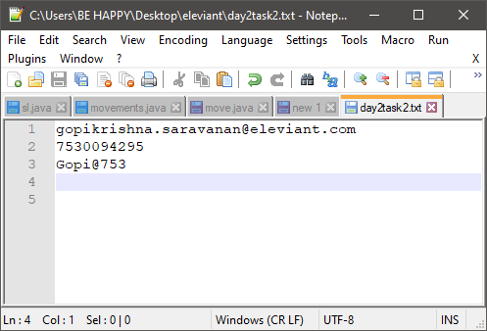

Reading the content in the file using stream reader function

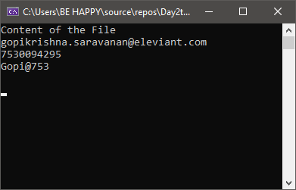

Getting string from user to store in the file

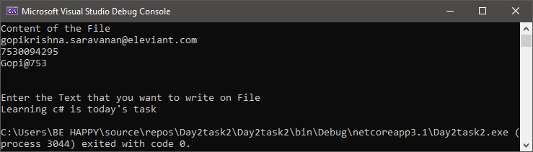

String is stored in the same file which is already exist

